Section 1: Case Summary

Scenario Title: | Severe COPD Exacerbation with Pneumothorax
Keywords: | Hypoxia, dyspnea, pneumothorax
Brief Description of Case: | 68M with respiratory distress. Known chronic obstructive pulmonary disease (COPD) on home O2, 3 days of worsening cough, sputum and dyspnea. Becomes increasingly distressed and agitated requiring intubation. Learners may consider non-invasive positive pressure ventilation (NIPPV) and delayed sequence intubation (DSI), but will require intubation. Shortly after intubation, becomes very difficult to bag and then becomes hypotensive. If not identified, the patient arrests from a tension pneumothorax.

Goals and Objectives
Educational Goal: | Appropriately manage the patient with a severe COPD exacerbation, with consideration of delayed sequence intubation, and recognition/management of the potential complications of positive pressure ventilation (PPV) in this patient subset.
Objectives:  (Medical and CRM) | - Manage the patient with a severe COPD exacerbation, including intubation  - Perform delayed sequence intubation  - Trouble-shoot increased airway pressures/difficulty bagging post-intubation  - Identify and treat a tension pneumothorax  - Maintain situational awareness and control of the room when managing an agitated patient  - Recognize a change in patient status
EPAs Assessed:

Learners, Setting and Personnel
Target Learners: | ☐ Junior Learners |  | ☒ Senior Learners |  |  | ☐ Staff
 | ☐ Physicians | ☐ Nurses |  | ☐ RTs | ☐ Inter-professional
 | ☐ Other Learners:
Location: | ☒ Sim Lab |  | ☐ In Situ |  |  | ☐ Other:
Recommended Number of Facilitators: | Instructors: 1
 | Confederates: 1
 | Sim Techs: 1

Scenario Development
Date of Development: | 14/03/2018
Scenario Developer(s): | Lindsey McMurray
Affiliations/Institutions(s): | The Ottawa Hospital
Contact E-mail: | mcmurray.lindsey@gmail.com
Last Revision Date: | 07/06/2020
Revised By: | Beatrix Bérczi
Version Number: | 2

Section 2A: Initial Patient Information

- Patient Chart
Patient Name: Peter Long |  |  |  | Age: 68 | Gender: M | Weight: 60 kg
Presenting complaint: Shortness of Breath
Temp: 37 ºC | HR: 120/min | BP: 160/95 |  | RR: 30/min | O₂Sat: 80% | FiO₂: 100% NRB
Cap glucose: 5 mmol/L |  |  |  | GCS: 11 (E4 V2 M5)
Triage note:
Patient has just arrived via EMS in severe respiratory distress. Patient is a known COPD patient on home O2. MD called to the bedside.

Allergies: NKDA
Past Medical History:  COPD (on home O2, 2L)  Hypertension  Smoker |  |  | Current Medications:  Tiotropium  Salbutamol PRN  Amlodipine

Section 2B: Extra Patient Information

A. Further History
Include any relevant history not included in triage note above. What information will only be given to learners if they ask? Who will provide this information (mannequin’s voice, confederate, SP, etc.)?

From home alone, no further history
B. Physical Exam
List any pertinent positive and negative findings
General Status: Distressed, sitting up, respiratory distress
Cardio: Normal heart sounds | Neuro: Eyes open, moaning intermittently
Resp: Diffuse wheeze/gasping | Head & Neck: Normal
Abdo: Normal | MSK/skin: Normal
Other: n/a

Section 3: Technical Requirements/Room Vision

A. Patient
☒ Mannequin: Adult
☐ Standardized Patient
☐ Task Trainer
☐ Hybrid
B. Special Equipment Required
Critical care supplies, Airway cart, NIPPV

C. Required Medications
Puffers/Aerochamber/Nebs
Intubation Kit
Arrest Kit

D. Moulage
None

E. Monitors at Case Onset
☐ Patient on monitor with vitals displayed
☒ Patient not yet on monitor
F. Patient Reactions and Exam
Include any relevant physical exam findings that require mannequin programming or cues from patient
(e.g. – abnormal breath sounds, moaning when RUQ palpated, etc.) May be helpful to frame in ABCDE format.
Dyspnea, gasping
Wheeze
Moaning intermittently
No verbal response

Section 4: Confederates and Standardized Patients

Confederate and Standardized Patient Roles and Scripts
Role | Description of role, expected behavior, and key moments to intervene/prompt learners. Include any script required (including conveying patient information if patient is unable)
Nurse | Skillful and cooperative bedside RN  Prompts to patient’s increasing agitation  Prompts to consider Hs & Ts during cardiac arrest

Section 5: Scenario Progression

Scenario States, Modifiers and Triggers
Patient State/Vitals | Patient Status | Learner Actions, Modifiers & Triggers to Move to Next State |  | Facilitator Notes
1. Baseline State  Rhythm: sinus  HR: 120  BP: 160/95  RR: 30  O₂SAT: 80% (neb)  T: 37ºC  GCS: 11 | Sitting up, distressed. Gasping for air. | Expected Learner Actions  Don appropriate PPE (Airborne precautions for COVID)  Focused history/physical  Monitors/IVs  100% O2 (non-rebreather)  ECG/Chest X-ray/Labs  Steroids and antibiotics  Bronchodilators  NIPPV  Attempt to clarify Code Status, ask for old chart | Modifiers  - O2 increases to 85% with NRB  Triggers  For progression to next state  - After 3-5 minutes → 2. Agitation
2. Agitation  HR: 130  RR: 30/min  O₂SAT: 85% (NRB) | RN prompts that patient is more agitated and grabbing at face mask | Expected Learner Actions  Consider delayed sequence intubation with ketamine  BVM with PEEP valve  Consider nasal prongs  Post intubation sedation | Modifiers  - With ketamine patient settles and can BVM with PEEP valve  - Once intubated, O2 to 92%, HR 90  Triggers  -2 minutes post-intubation → 3. Pneumothorax
3. Pneumothorax  Rhythm: sinus  HR: 130  BP: 70/50  RR: 16/min  **no air entry Right chest**  O₂SAT: 80% (Vent) | Patient develops obstructive shock from tension pneumothorax  If patient arrests, RN may prompt learner to consider Hs & Ts of ACLS | Expected Learner Actions  Troubleshoot high airway pressures. (Disconnect from vent, BVM, manually compress chest, suction, assess for pneumothorax)  Needle decompress/finger thoracostomy one or both sides.  Chest tube insertion  Call ICU | Modifiers  - Once pneumothorax is identified and decompressed, O2 and BP improve.  Triggers  -If pneumothorax not identified, after 2 minutes, patient has PEA arrest which will resolve with decompression.

Appendix A: Laboratory Results

VBG
pH 7.15
pCO₂ 80
pO₂ 38
HCO₃ 29
Lactate 4

Appendix B: ECGs, X-rays, Ultrasounds and Pictures

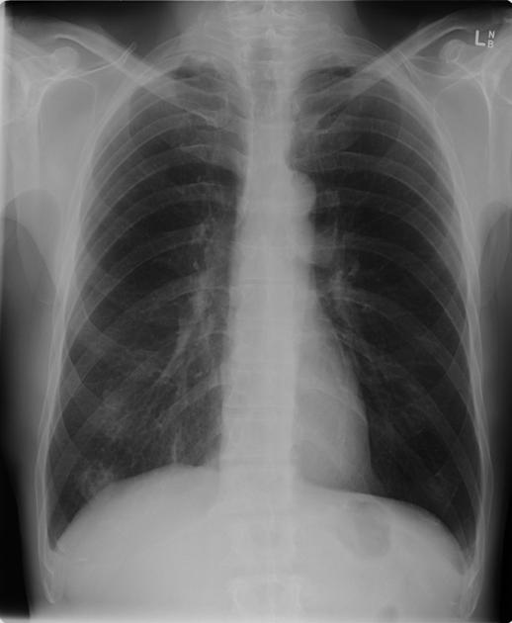
Chest xray from radiopaedia.org
https://radiopaedia.org/articles/chronic-obstructive-pulmonary-disease-1

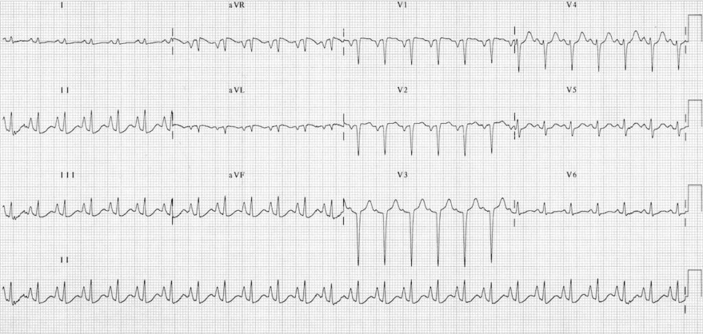
ECG from LITFL
https://litfl.com/ecg-in-chronic-obstructive-pulmonary-disease/

Ultrasound
Before intubation: COPD clip (A lines)
After intubation: Pneumothorax clip (no lung sliding)

Appendix C: Facilitator Cheat Sheet & Debriefing Tips

Include key errors to watch for and common challenges with the case. List issues expected to be part of the debriefing discussion. Supplemental information regarding any relevant pathophysiology, guidelines, or management information that may be reviewed during debriefing should be provided for facilitators to have as a reference.

Sample Debriefing questions:

Clinical Debrief
- What are your options for optimizing oxygenation in the agitated hypoxic patient? How do you optimize pre-oxygenation if your patient requires intubation (DSI)?
- How do you trouble shoot high airway pressures, and what are the differentials to consider. How do we clinically apply the DOPE mnemonic?
- In a patient who arrests after high airway pressures on a vent, how do your priorities change vs. a non-intubated PEA arrest patient (i.e. have a high suspicion for tension pneumothorax & have low threshold to decompress chest).

CRM Debrief
- What techniques can be used to maintain situational awareness when critical procedures are required during a resuscitation (i.e. intubation, chest decompression).
- What strategies can be used to maintain control in a chaotic resuscitation with an agitated patient?

Key Moments:
- Approach to/ use of DSI to optimize pre-oxygenation for emergent intubation
- Intubation of a hypoxic patient
- Recognition of increased airway pressures, and pneumothorax post intubation

References

1. ttps://lifeinthefastlane.com/ccc/delayed-sequence-intubation/
2. https://emcrit.org/preoxygenation/
3. https://lifeinthefastlane.com/ccc/high-airway-and-alveolar-pressures/

